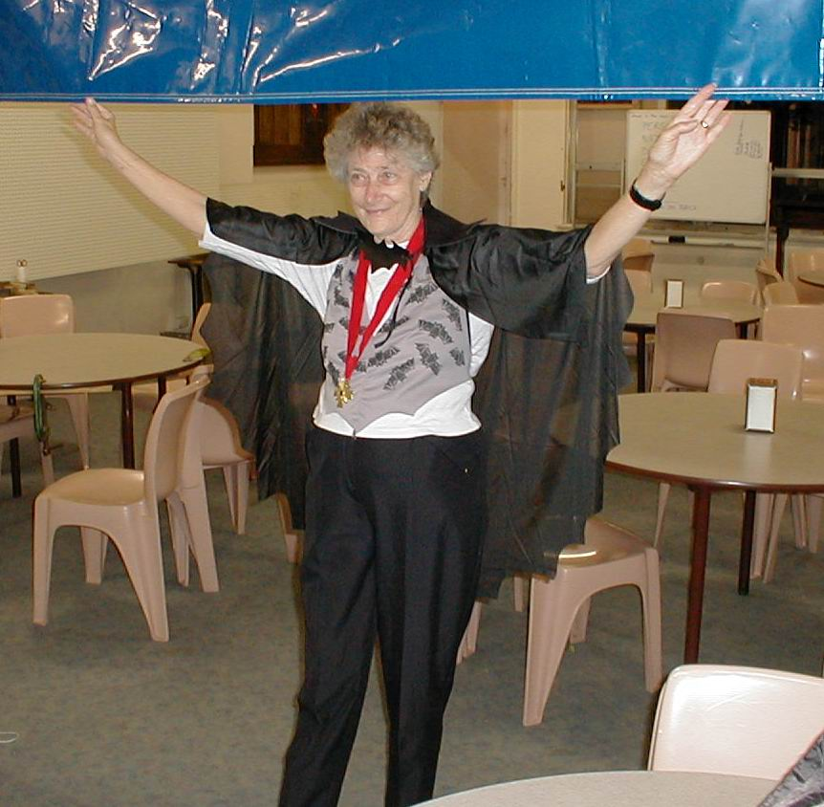
Joan Crabb in bat costume

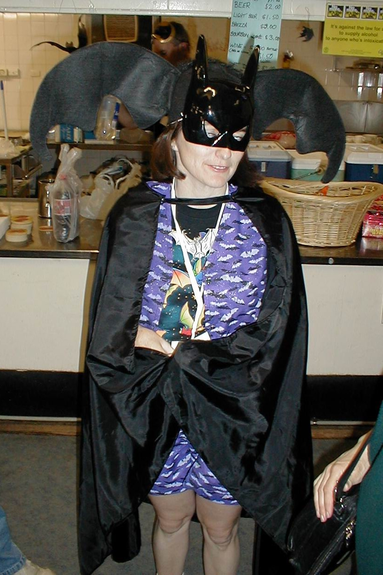
Jenny Whitby as bat girl

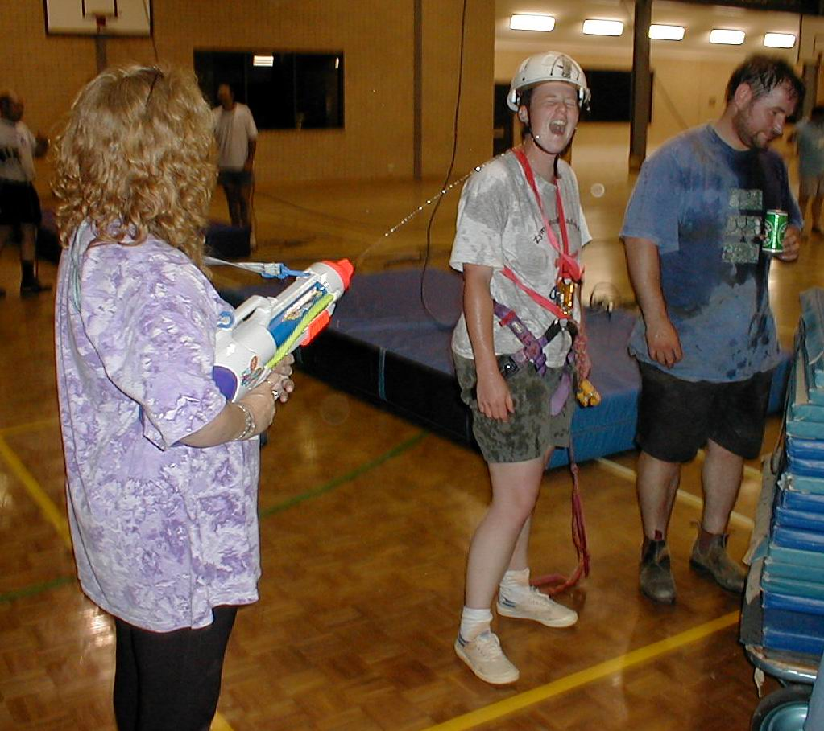
Marie Choi cools Kath Rowsell’s enthusiasm

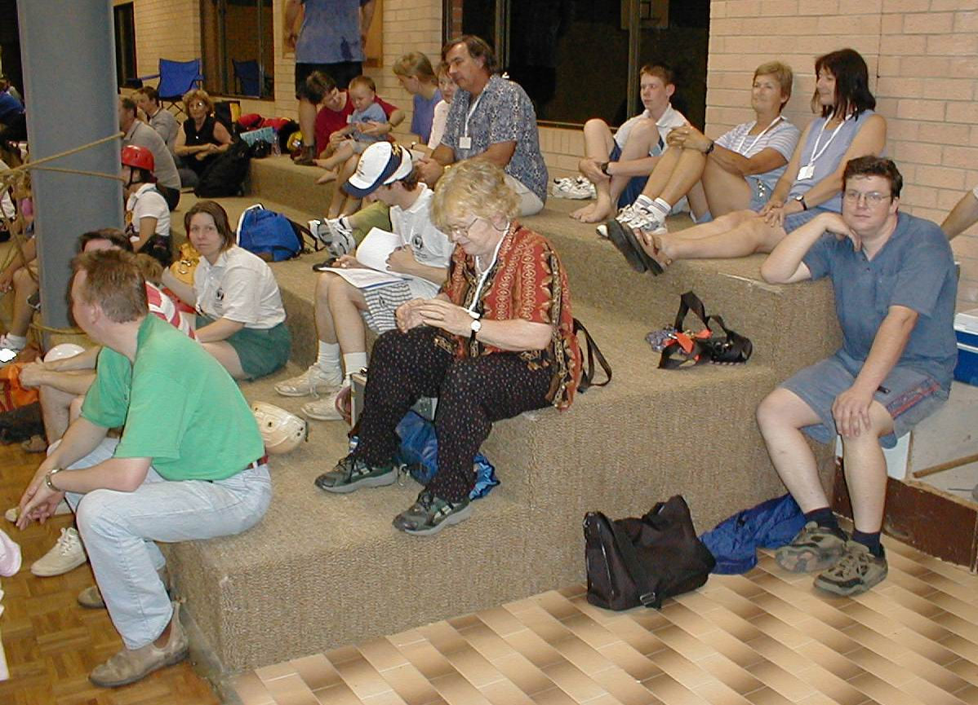
Fascinated spectators at the prussik challenge

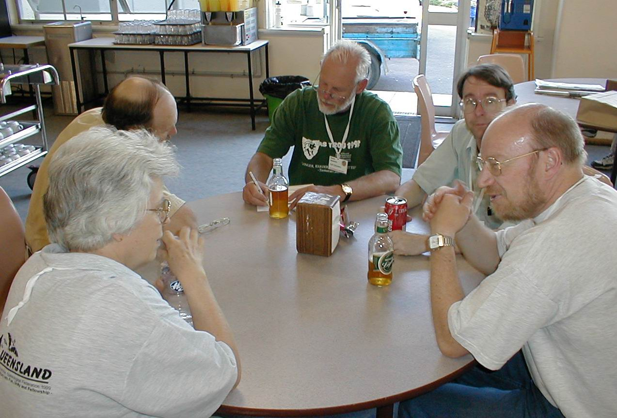
Pre-dinner drinks

